How to delete emails in WorldClient (Web-Based Email Client)
Learn how to delete emails from your mailbox in WorldClient (Web-Based Email Client). For each email address tied to your Selia Group Account, Webmail provides 300 MB of email storage. As you reach this threshold, we send out a notification that you are nearing your quota. In order to resolve this issue, you will need to delete some emails to free up storage space and to avoid not receiving incoming emails.

There are a couple of ways that you can delete emails from WorldClient (Web-Based Email Client):
- Sign in to Webmail at http://mymail.seliagroup.com:3000/

- From your email inbox, highlight the message that you would like to delete and perform one of the following:

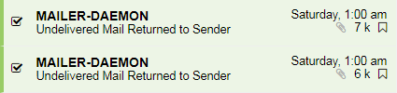

- Right click on the email and select Delete from the options menu.

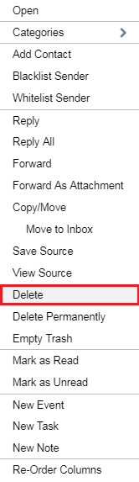

- Highlight the email and select the Delete Icons option from the top menu.

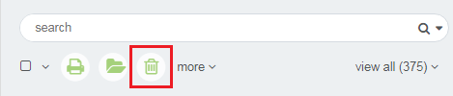

- Right click on the email and select Delete Permanently from the options menu.

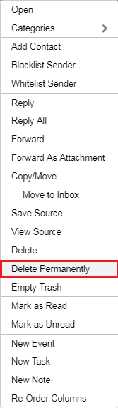

- You can set up a filter to automatically delete or sort messages from a specific sender. This is done through search bar. For additional details see automatically delete or sort messages from a specific folder.

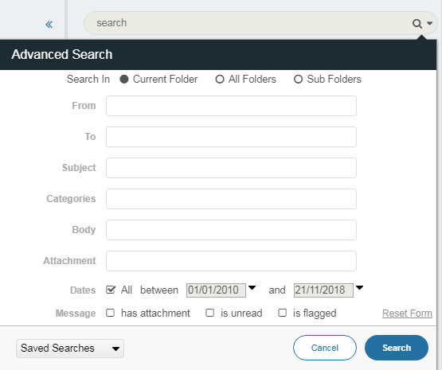

How to delete multiple emails
You can delete multiple emails by clicking the checkbox beside each email in your Inbox or email folder that you wish to delete emails from. Deleting emails in this manner places them in your Deleted Items folder. To permanently delete these emails you will need to right-click the Deleted Items folder and select Empty Trash.
